Health Care Satisfaction Analysis

Project Overview
This Project designed to evaluate patient satisfaction level across U.S hospitals. The main goal was to uncover insights into hospital ratings, survey response rates and satisfaction trends, helping healthcare consultants identify improvement areas and benchmark facilities effectively.

Tools and Technology Used
- Microsoft Excel – Data Cleaning, preprocessing and exploration.
- MYSQL (XAMPP) – Database setup and advanced SQL querying.
- Power BI – Data Visualization and dashboard development.
- Python (Pandas, SQLAlchemy) – Data transformation and analysis.

Data Source
Dataset: Healthcare_Survey.xlsx
Source: CMS Hospital Compare
Contains patient survey response from hospitals across US, including:
- State, Facility ID, Zip Code
- HCAHPS Questions & Categories
- Patient Survey Star Rating
- HCAHPS Linear Mean Value
- Response Rate (%)

Exploratory Data Analysis using Python
We began with data preparation and cleaning in Python:
- Data Loading: Imported the dataset using pandas.
- Initial Exploration: Used df.info() to check structure and .describe() for summary statistics.
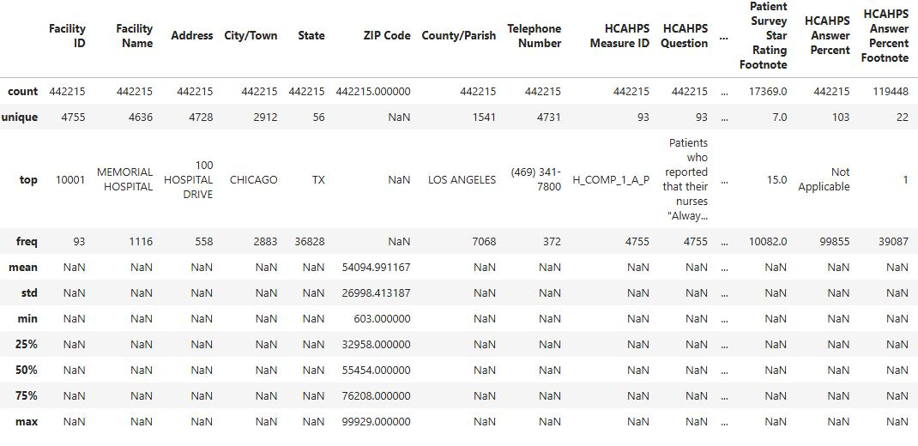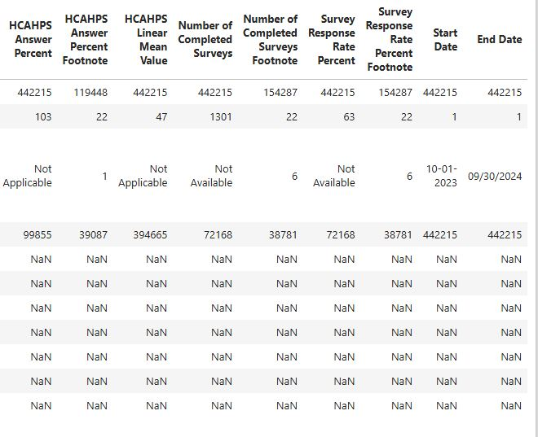
- Columns Standardization: Renamed columns to Snake case for better readability and documentation.
- Feature Engineering:
  - Created Survey_Period_Days column from End_Date to Start_Date.

  - Created Response_Rate_Category column from Survey_Response_Rate_Percent.

  - Created Satisfaction Level Column from Patient_Survey_Star_Rating.

  - Created Rating_to_Response_Ratio column from Survey_Response_Rate_Percent and Patient_Survey_Star_Rating.

  - Created Question_Category column from HCAHPS_Question.

  - Created Top_Performance column from Patient_Survey_Star_Rating.

- Database Integration: Connected Python script to MYSQL and loaded the cleaned DataFrame into the Database for SQL analysis.

Data Analysis using SQL
We performed structured analysis in MYSQL to answer key questions:
- Total Number of Hospitals
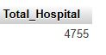

- Top 10 States with most Hospitals
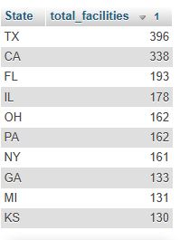
- Survey Star Rating by State
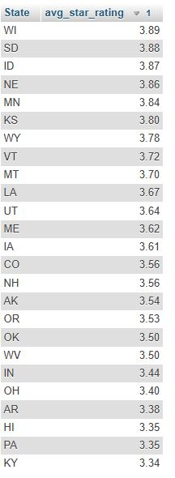
- Performance Score by Satisfaction Level
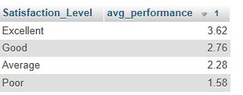
- Hospital with rating below average of their state
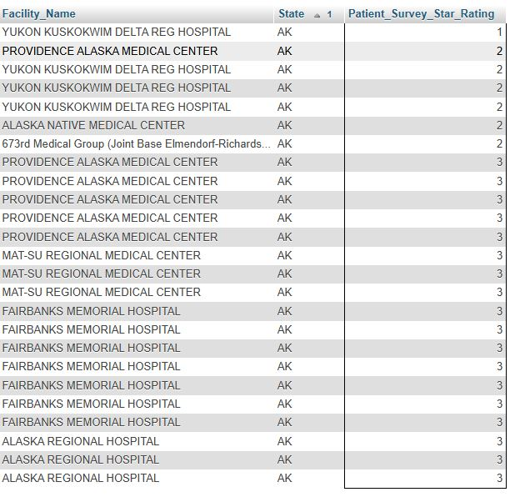
- Satisfaction by Question Category
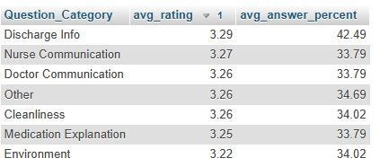

- Survey Complete and Response Rate per state
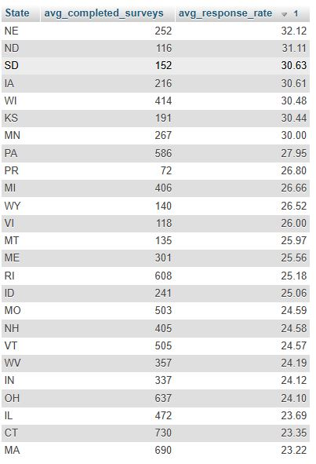
- Top10 Facilities with highest star rating
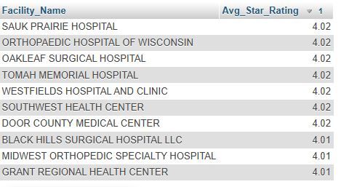
- Satisfaction by State
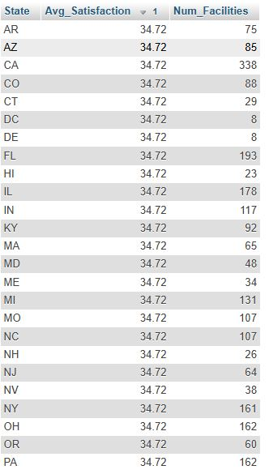
10.Year Wise Performance Trend
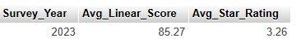
11. Satisfaction Level Distribution
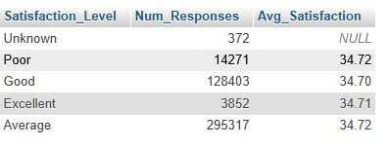
12. Facilities with best Rating to Response Ratio
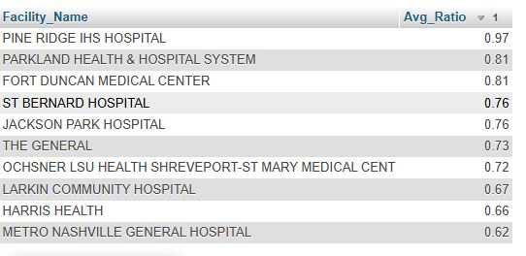
13. Underperforming Facilities
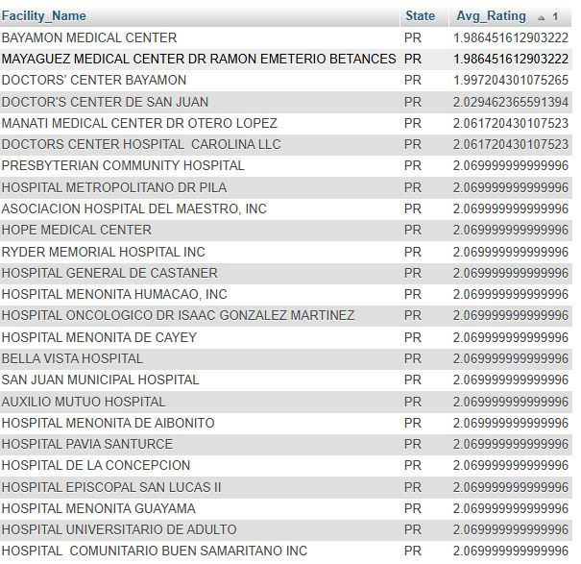

Dashboard in Power BI
Finally, we built an interactive dashboard in Power BI to present insights visually.
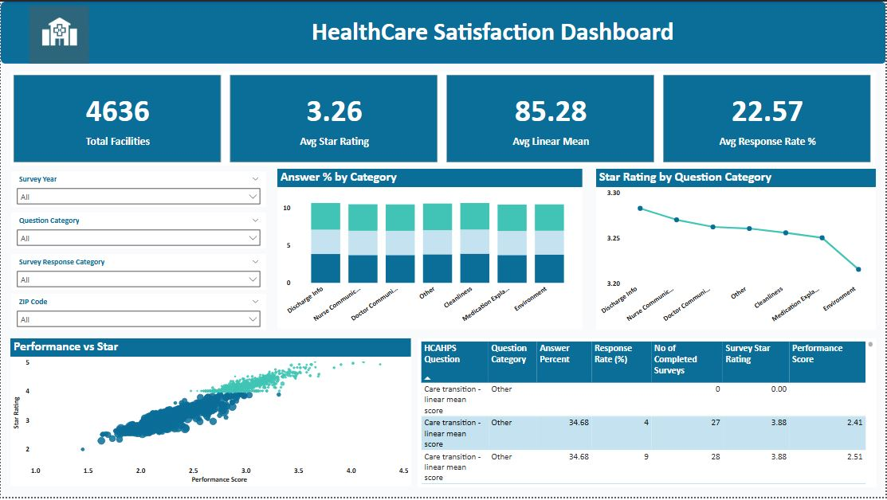
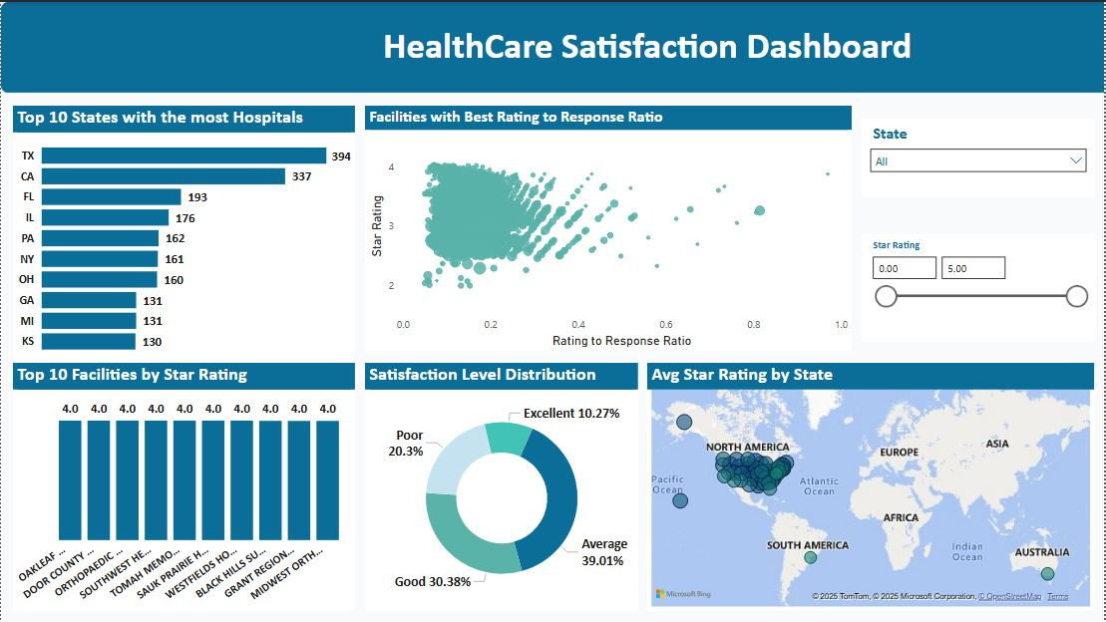

Key Insights
- Texas, California, and Florida have the highest number of healthcare facilities.
- Average patient satisfaction lies between 3.0 and 3.5 stars, with an average response rate of 22.57%.
- Higher linear mean scores correlate with improved star ratings.
- Over 30% of patients rate hospital experiences as Good, while 10% mark them as Excellent.
- Some facilities show low response rates despite high satisfaction — indicating scope for improved engagement.

